Creating an Action Group in Azure SOP



Table of Contents

1. Creating an Action Group in Azure 3
1.1 Description 3
1.2 Architecture Diagram 3
1.3 Lab Steps 4
1.4 Troubleshooting 4
1.5 Supporting References 4

Creating an Action Group in Azure

Description
An action group is a collection of notification preferences defined by the owner of an Azure subscription. Azure
Monitor and Service Health alerts use action groups to notify users that an alert has been triggered. In this handson lab, you will create an action group and configure it so that an individual or group of people will receive alerts for predefined events.

Architecture Diagram
The diagram below displays a visual representation of the application architecture:
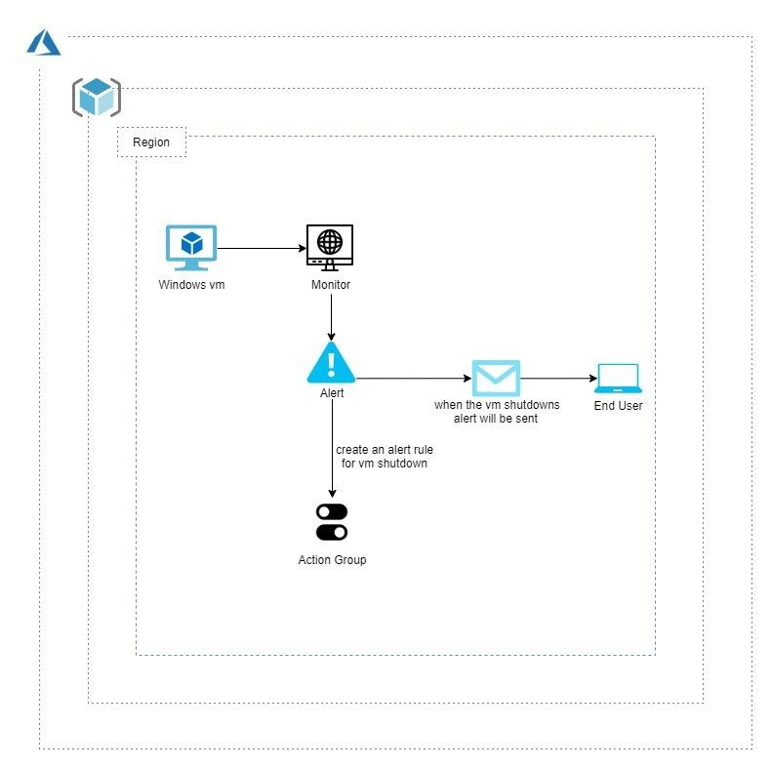

Lab Steps
Follow the steps outlined below to achieve the objective of this lab exercise:

- Login to the azure portal.
- Go to all resources and create a virtual machine.
- Navigate to monitor section.
- Click on Alerts in the monitoring section.
- Click Manage actions from the top of the window.
- Click + Add action group from the top of the window.
- In that action group enter required details, provide the name of your Resource Group wherever required (<Dept><EmpID>RG).
- Under action type, click the box and select email/push/SMS/voice.
- Click Edit details.
- Select the way you would like to receive notifications. In this example, we select an SMS/Email notification. Provide required details and click OK.
- Click activity log present below Overview blade.
- Go to the virtual machine and stop it.
- Navigate to monitor once again and click on activity log.
- Refresh the activity log which takes some time for logs to reflect.
- Click on the event named Deallocate Virtual Machine.
- Click on New alert rule and provide the required details.
- Type VM shutdown under Alert rule name.
- Click Create alert rule.
Note: After the rule has been created, you should now see a text or email notification whenever the machine is shutdown. You can start and stop your VM and check if you are receiving the notifications now.

Troubleshooting
S. No | Problem | Solution
1 | Facing a validation error while creating a VM | Check for the following:  - In general, there may be fault in size selection and this can be solved by going through the recommended sizes and also can use standard size (B1s).  - Check the region where the VM is to be created.

Supporting References
Refer the below link for additional information:

1. https://docs.microsoft.com/en-us/azure/azure-monitor/platform/action-groups

